

Progressive Cavity Pump Controller

**Firmware Version**

1.07

**Manual Revision**  
1.00

User Operation and Configuration Manual

# Table of Contents

Table of Contents 2

Specifications 3

Wiring Diagrams and Schematics 4

Graphical User Interface 6

Parameters 11

Factory Reset 25

Technical Support 26

# Specifications

|  |  |
| --- | --- |
| **Technical Specifications** | |
| Input Voltage | 24 VDC |
| Maximum Current Consumption | 270 mA |
| Battery-Backed RAM | 7 year typical at 25 °C, replaceable without opening the controller. |
| Display Size and Resolution | 5.7 Inch, 320x240 Pixels |
| Display Colors | 65,536 (16-Bit) |
| Touchscreen | Analog Resistive |
| Keypad | On-Screen Only |
| Digital Inputs | 7 Total, NPN  5, General Purpose  2, Dedicated Purpose |
| Analog Inputs | 2, 0-10 VDC  1, 4-20 mA |
| Digital Outputs | 2 Relay  4 Transistor |
| Serial Ports | 2 Serial  RS232/RS485 with galvanic isolation.  Port 1 is dedicated to SCADA communication.  Port 2 is dedicated to VFD communication.  1 USB  Used for programming and PC access.  COM Port 1 is disabled when using USB connected to a PC. |
| Date, Time, and Supervisor | Real-Time Clock and Watchdog |
| Parameter and Event Storage | Removable SD Card |
| Temperature | Operation: 0 to +50 °C (32 to 122 °F)  Storage: -20 to +60 °C (-4 to 140 °F) |
| Humidity | 5 % to 95 %, non-condensing |
| Physical | 7.75” x 5.77” x 2.7” (197 mm x 146.6 mm x 68.5 mm) |

# Wiring Diagrams and Schematics

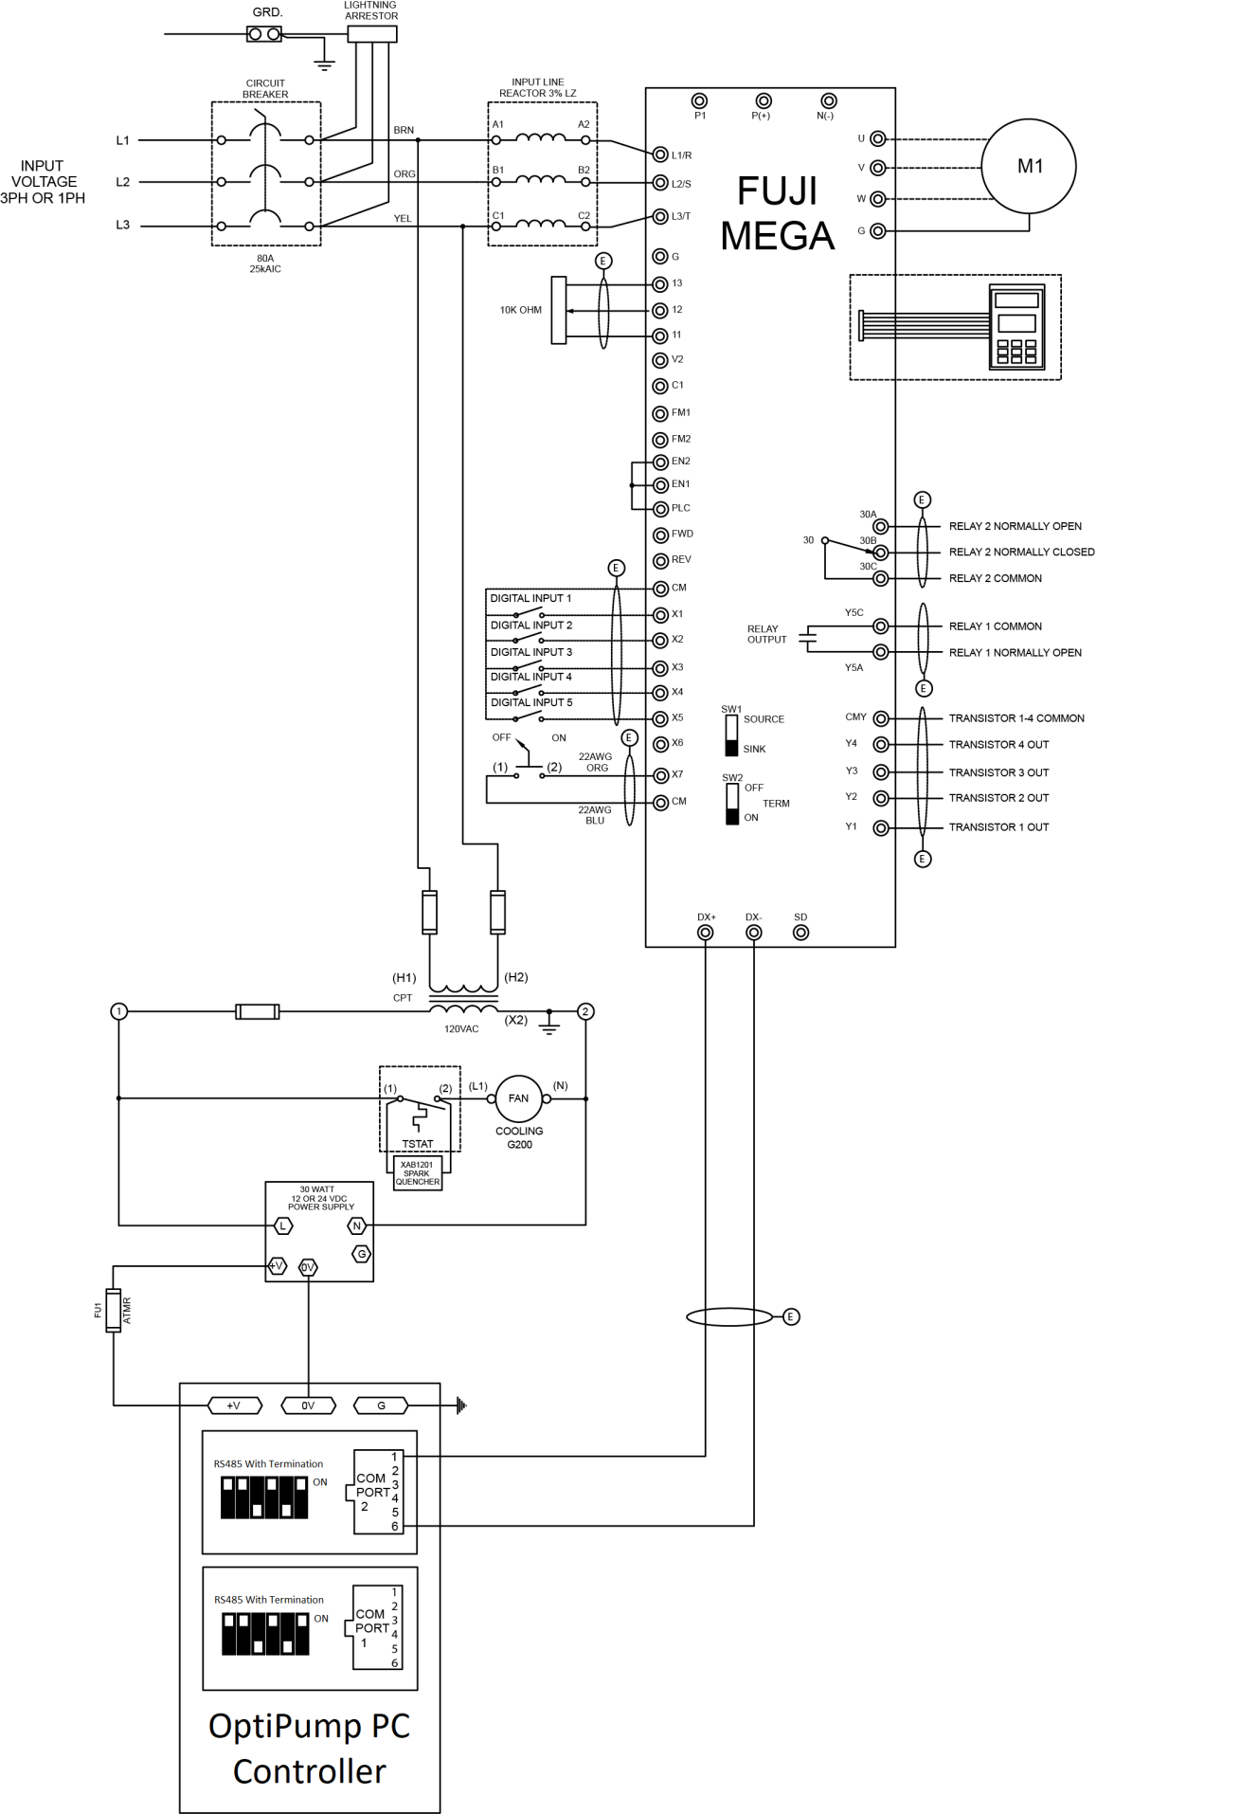

**! CAUTION !**

Always verify that the power has been disconnected from both the OptiPump PC controller and the Fuji Mega variable frequency drive (VFD) before making changes to the wiring.

Failure to do so may result in severe injury or death!

High DC voltages may still be present for a period of time after main power has been removed from the variable frequency drive. Take note of the red **Charge** LED, labeled CRG, located on the drive. Depending on the size of the drive, the LED may be visible through the front cover. The LED will go dark when the DC bus has been discharged. Until then, potentially dangerous voltages may still be present for several minutes after disconnecting power.

You should always verify that terminals are no longer powered by using a properly working and tested multimeter.

**Attention:**

When wiring 4-20 mA transducers to the system, the use of shielded, twisted cable is REQUIRED. Failure to use shielded, twisted signal cable may result in unexpected or erratic behavior.

The shield/drain wire should be connected to an earth ground at ONE end of the cable only. Do NOT connect both ends of the shield/drain wire to earth ground. Doing so may result in unexpected or erratic behavior.

Do NOT run transducer signal cables in the same duct or conduit as the VFD motor or other power leads. Transducer signal cables should be run only with other low voltage, DC signal cable.

# Graphical User Interface

|  |
| --- |
| **Navigation** |

The OptiPump PC controller on-screen interface is navigated using the touchscreen. Elements that are touch-sensitive are marked with a dark blue background with white text. A few examples are shown below, with several (but not all) of the buttons circled in red.

Buttons that perform critical or non-reversible functions (such as clearing history items) may be marked in yellow or red to indicate to proceed with caution.

All parameter screens have a Menu button located in the lower center of the screen. Pressing the Menu button will return you to the menu for the group of parameters currently displayed.

Remember, if for some reason you ever find yourself lost in the interface, simply press the Menu button located in the lower center screen to return instantly back to the menu. Then, to return to the Home Screen, press the Home button located in the lower center of the screen of any menu.

|  |  |
| --- | --- |
|  | ButtonsEg2.png |
|  |  |

|  |
| --- |
| **Home Screen** |

|  |  |  |
| --- | --- | --- |
|  |  |  |
| **Normal Operation** |  | **Alarm / Fault Present** |

The Home screen provides an overview of the current operating conditions of the system.

Four user-selectable monitors are displayed on the left of the screen, with the system status and total run hours displayed on the right. The VFD status is displayed just above the navigation buttons. Depending on the status of the system and VFD, these monitors will change color to provide a quick visual indication of the status.

The navigation buttons located at the bottom of the Home Screen provide quick access to important system information and configuration settings.

**Well Metrics** – Charting of critical system values.

**Alarms** – Detailed information about system alarms and VFD faults.

**Status** – Detailed I/O status and VFD diagnostic information.

**Setup** – Configure the system using application and site-specific settings.

|  |
| --- |
| **Well Metrics** |

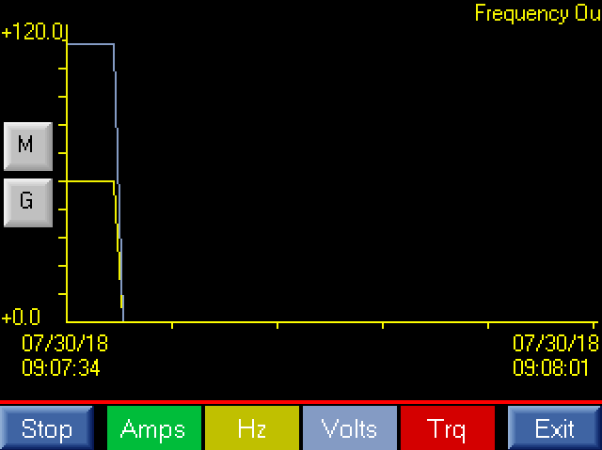Well Metrics provides real-time charting of voltage, current, frequency, and torque, which allows a user to quickly get an overview of the pump operation over time.

This feature presents the most valuable trending data all in one place, to make it simple to diagnose performance issues with the pump.

The Start / Stop button located in the lower-left corner of the screen starts and stops the charting function. The multicolored buttons for Amps, Hz, Volts, and Trq toggle the individual plots above.

|  |
| --- |
| **Menus** |

|  |  |  |
| --- | --- | --- |
| **SystemStatus1.png** |  | **Menu Alarms.png** |

The Setup Menu provides a central location for managing the configuration of the OptiPump PC controller. Each of the parameter groups is described in further detail in the Parameters section of this manual.

The Setup Menu is protected by a user-definable password. The default value for this password is “444”.

The Alarms Menu separates the alarms/shutdowns into System and VFD specific types, and provides the option to delete the history via the Clear History button. In order to prevent unintended clearing of the alarm/shutdown history, the Clear History button must be held for 5 seconds to access this feature.

|  |
| --- |
| **Alarms** |

|  |  |  |
| --- | --- | --- |
|  |  | Alarm Info VFD.png |

System Alarms / Shutdowns include non-VFD related alarms/shutdowns, such as underload, overload, analog and digital inputs, etc.

VFD Alarms / Shutdowns include only VFD-related alarms/shutdowns. These alarms/shutdowns are the result of a VFD fault, which will display an error code on the VFD keypad.

When an alarm/shutdown occurs, a detailed snapshot of the operating conditions at the time is stored in history. 200 snapshots each, of both System and VFD, are retained in history for review, and can be very helpful when troubleshooting potential problems.

Clearing the alarm/shutdown history permanently deletes the history – it cannot be recovered, so please use caution when selecting this item from the Alarms Menu.

|  |
| --- |
| **Status** |

|  |  |  |
| --- | --- | --- |
| **SystemStatus1.png** |  | **SystemStatus2.png** |

The VFD and System Status screens provide a broad overview of current operating conditions, and can be very useful when commissioning a new site, or troubleshooting configuration or installation problems.

When the digital inputs (X1 – X7) and outputs (Y1 – Y5, 30) are active, a “1” is displayed below the corresponding input or output. A “0” is displayed below the corresponding input or output when it is inactive.

|  |
| --- |
| **Manual Control** |

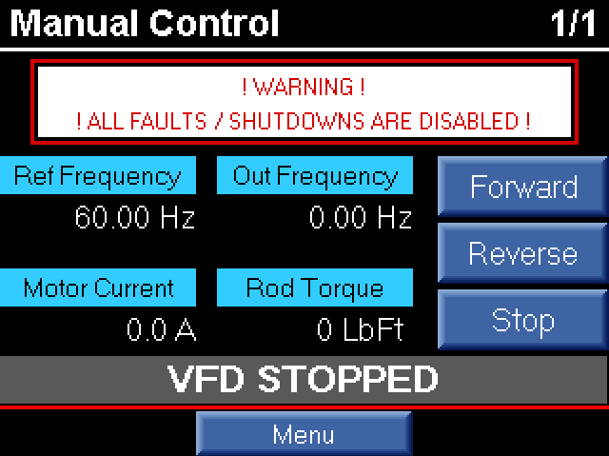During commissioning or troubleshooting, temporarily disabling the shutdowns may be useful. The Manual Control feature, accessible from the Setup Menu, allows a user to operate the pump with all shutdowns temporarily disabled.

In order to access this feature, the Manual Control button on the Setup Menu must be held for 5 seconds.

After leaving this screen, by pressing the Menu button, all previously defined shutdowns will become active again, and the system will return to normal operation.

# Parameters

|  |
| --- |
| **Motor Parameters** |

|  |  |
| --- | --- |
| Motor 01.png | Motor 02.png |
| Motor 03.png | Motor 04.png |

For Underload and Overload related parameters, the real-time monitors for Setpoint, Motor Current, Rod Speed, and Rod Torque are displayed at the top of the screen for reference.

The Underload and Overload features can be tripped using motor current, rod torque, or both. For most PC pump applications, rod torque will be selected.

The controller can react to an Underload or Overload condition with No Shutdown, Shutdown with Manual Reset, or Shutdown with Timed Restart.

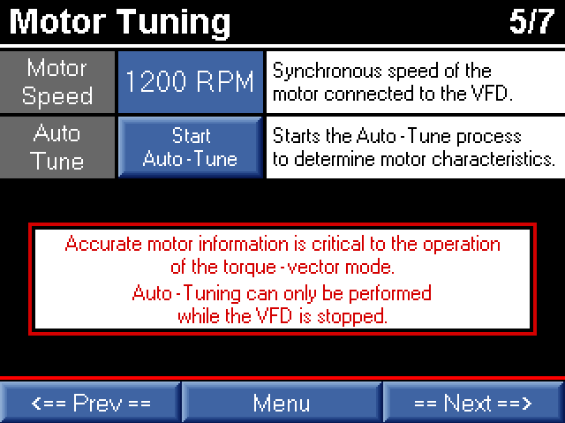For PC pump applications, accurately tuning the motor is a critical step in the commissioning process. This requires the motor nameplate information be readily available: rated horsepower, rated speed, and full-load amps.

Select the appropriate Motor Speed, then press the Start Auto-Tune button and follow the on-screen instructions.

The VFD **MUST BE STOPPED** before performing the Auto-Tune procedure. Verify that the motor is not still spinning as well.

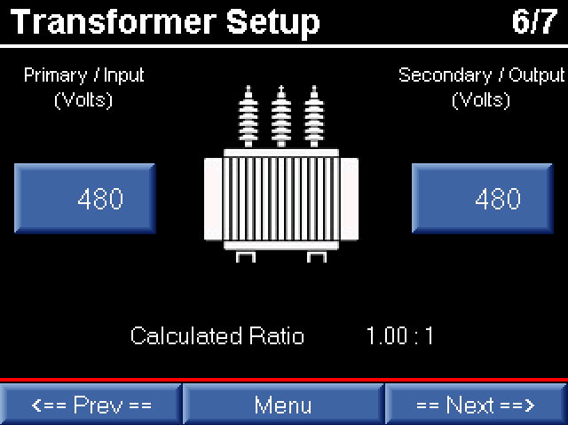In cases where an output transformer is connected to the VFD, the motor voltage and current can automatically be calculated based on the transformer primary/secondary ratio.

Rather than manually calculating this ratio, the OptiPump PC controller can determine the ratio by simply entering the rated voltage taps configured at the site.

For example, if the primary rating of the output transformer is 480 VAC, and the secondary of the transformer is tapped at 1000 VAC, simply enter these values in the Primary / Input (Volts) and Secondary / Output (Volts) parameters. The OptiPump PC controller will automatically calculate a ratio of 2.08:1, and display the correct Xformer Output Voltage and Xformer Output Current on the Home Screen monitors.

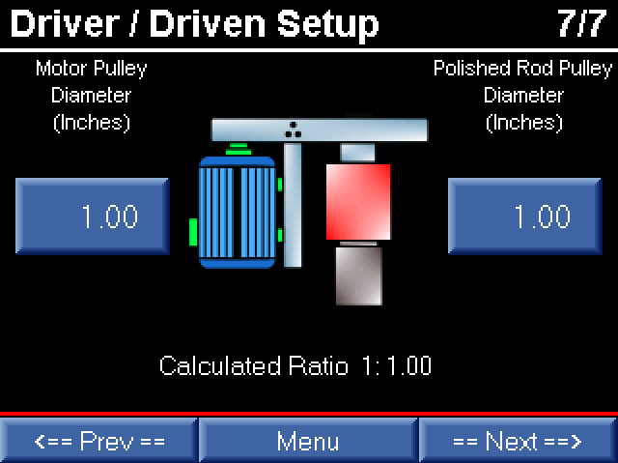A PC pump drive head typically includes a set of pulleys used to slow the speed and increase the available toque of the rod string. Since the rod string has a rated maximum torque that can result in damage if exceeded, determining the accurate rod torque is critical to the operation of a PC pump. The OptiPump PC controller provides a simple method of determining the pulley ratio for these applications.

In order for the OptiPump PC controller to calculate the pulley ratio, only the motor and polished rod pulley diameters are needed. These values may be obtained either through the specifications on the drive head, or by simply measuring the pulley diameters with a tape measure.

Once the pulley diameters are known, the values are entered into the parameters Motor Pulley Diameter (Inches) and Polished Rod Pulley Diameter (Inches). The OptiPump PC controller will automatically calculate the ratio.

When setting Underload, Overload, and Limiting values for Torque, please note that these values are in Polished Rod Torque Lb-Ft, and are calculated by using the motor torque and the pulley ratio.

|  |
| --- |
| **Operation Parameters** |

The Operation parameters control the behavior and reactions of the system to application and site-specific requirements.

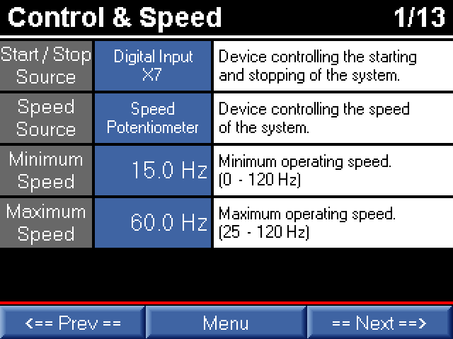Control & Speed parameters determine which device controls the starting and stopping of the system, as well as the how the speed is controlled. The subsequent parameter screens will apply depending on the parameter values chosen on this screen.

The Minimum Speed and Maximum Speed, which apply to all operation and control methods, are also set on this screen.

**Start / Stop Source**

*Digital Input X7* – The system will run when terminal X7 is closed.

*Analog Input C1 Level* – Start and stop will be based on set levels of Analog Input C1.

*Analog Input V2 Level* – Start and stop will be based on set levels of Analog Input V2.

*Time Clock* – Run and stop durations will be based on set times.

*SCADA Remote Control* – A remote device will start and stop the system.

**Speed Source**

*Speed Potentiometer* – The system speed will be manually set using the speed-pot connected to T12.

*Analog Input C1 Tank Drain* – When used to drain a tank, the OptiPump PC controller will automatically decrease the speed as the tank level decreases based on Analog Input C1 (see Analog Speed Tank Drain parameters later in this manual).

*Analog Input V2 Tank Drain* – When used to drain a tank, the OptiPump PC controller will automatically decrease the speed as the tank level decreases based on Analog Input V2 (see Analog Speed Tank Drain parameters later in this manual).

*SCADA Remote Control* – A remote device will set the speed of the system.

*Analog Input C1 PID* – The system will attempt to maintain a level using PID control, with the feedback as Analog Input C1.

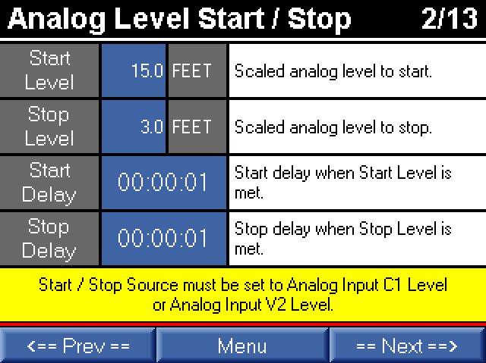Start / Stop Source must be set to Analog Input C1 Level or Analog Input V2 Level in order for these parameters to apply.

The OptiPump PC controller can start and stop based on the level of Analog Input C1 or Analog Input V2. The Start and Stop Levels are based on the scaled (engineering unit) values configured for the chosen analog input.

The system will start when the analog input level is equal to the Start Level for the time set by Start Delay, and the system will stop when the analog input level is equal to the Stop Level for the time set by Stop Delay.

The default values for the Start Delay and Stop Delay are 1 second. Depending on how steady the signal from the analog input is, either electrically from noise or mechanically from the process, the time may need to be extended in order to prevent the system from starting and stopping too quickly.

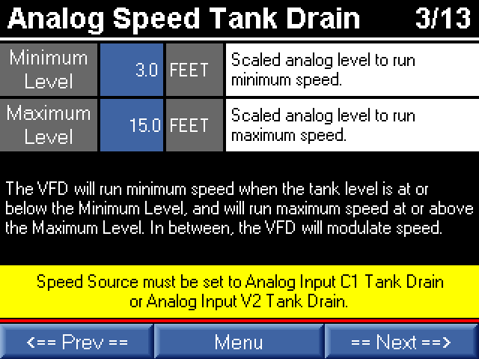Speed Source must be set to Analog Input C1 Tank Drain or Analog Input V2 Tank Drain in order for these parameters to apply.

Analog Speed Tank Drain offers an alternative to PID control for tank drain applications. Rather than spending time tuning the PID settings in order to maintain a tank level, this method requires only two parameters to be set.

The system will run at Minimum Speed at or below the Minimum Level parameter, and at Maximum Speed at or above the Maximum Level. In between these points, the VFD will scale the speed linearly, like a traditional signal-following setup. This allows the controller to find a level between the two points that matches the inflow rate. Think of this method as defining the tank levels that the application can tolerate, and the system will find a value within that tolerance to maintain.

Both the Minimum Level and Maximum Level parameters are based on the scaled (engineering unit) values configured for the chosen analog input.

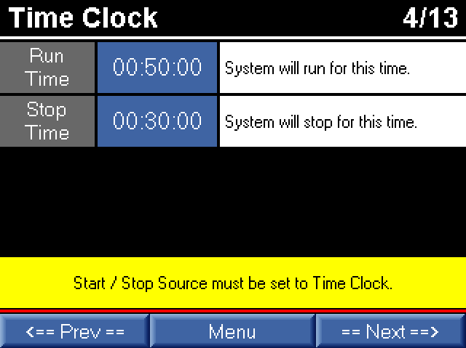Start / Stop Source must be set to Time Clock in order for these parameters to apply.

The Time Clock operation mode works just like a traditional mechanical time clock, without accounting for the time of day. The system will run for the time set in Run Time, and then stop for the time set in Stop Time.

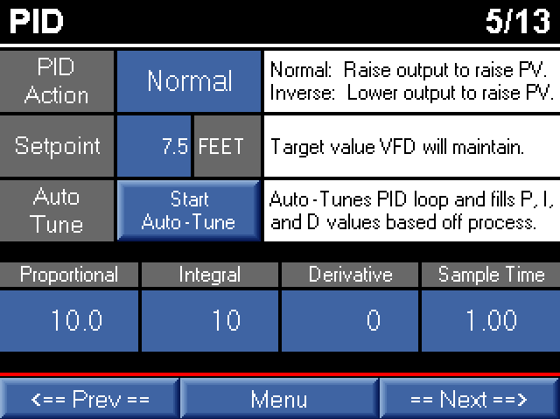Speed Source must be set to Analog Input C1 PID in order for these parameters to apply.

PID speed control attempts to maintain a specific value set by the parameter Setpoint. The Setpoint is scaled using the same units as the Analog Input C1.

The PID Action controls the response of the controller to a change in the feedback. A Normal response causes the VFD speed to increase in order to increase the value of Analog Input C1. An Inverse response causes the VFD speed to decrease in order to increase the value of Analog Input C1.

Tuning the PID response by hand can be a time-consuming process. The OptiPump PC controller includes an auto-tuning function for the PID control that can dramatically decrease the time required for tuning the response. While the system is running, press the Start Auto-Tune button to begin the process. Please be aware that the auto-tuning process can force the speed of the pump to the set limits, as well as overshoot and undershoot the target Setpoint. The process must be capable of handling these reactions safely in order to use the auto-tuning feature.

The Proportional, Integral, Derivative, and Sample Time parameters will automatically be set by the auto-tuning process, but can be overridden or set by the user, if necessary.

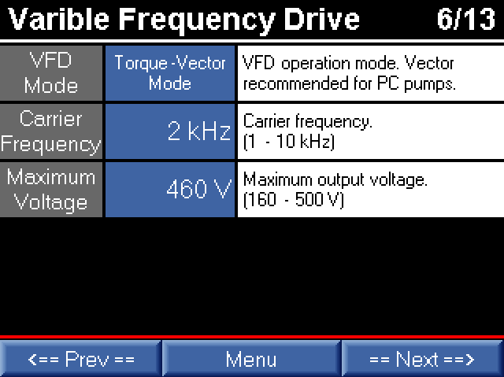General, VFD-related parameters are available on the Variable Frequency Drive parameter screen. Typically, these parameters only need to be set during the initial commissioning of the site or system.

The VFD Mode switches between V/Hz and Torque-Vector operation modes. V/Hz mode simply creates a predefined relationship between the output voltage and frequency from the VFD. This is the most basic operation mode of a VFD. Torque-Vector mode allows the drive to automatically determine the torque requirements of the load, and increase available torque to prevent the motor from stalling. Generally, the Torque-Vector mode allows for 100% motor torque throughout the speed range of the motor, and is the recommended VFD mode for PC pump applications.

For PC pump applications, the Carrier Frequency plays a role in how smoothly and quickly the VFD reacts to changes in torque requirements. Ideally, this value should be set as high as possible. However, increasing the Carrier Frequency also increases the electrical noise generated by the VFD, as well as the heat generated by the VFD. The recommended Carrier Frequency for most applications and sites is 6 kHz. This provides a good balance between torque control, electrical and audible noise, and heat generation.

The Maximum Voltage should be set to match the rated voltage of the motor.

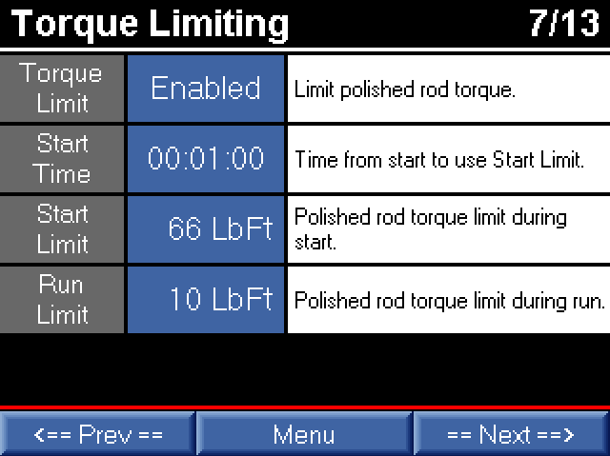The OptiPump PC controller includes high-speed torque limiting that protects costly PC pump components, and can be easily enabled using the Torque Limit parameter. All limits are set in Polished Rod Lb-Ft, and automatically take into account the configured pulley ratio on the drive head.

For applications where a higher or lower startup torque is required, a Start Limit can be configured. The Start Limit applies for the Start Time during startup. After the Start Time elapses, the Run Limit applies.

The torque limiting feature relies on having accurate motor information and successfully performing the auto-tuning procedure prior to operation.

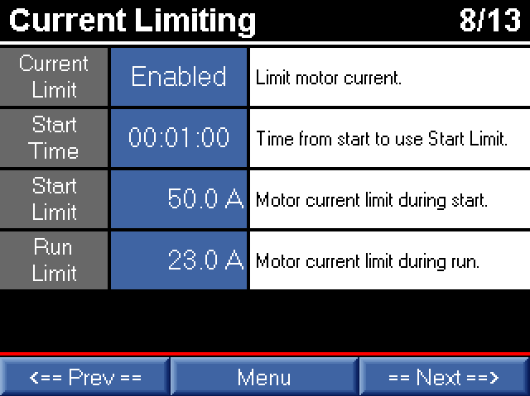In addition to limiting torque, the OptiPump PC controller can limit motor current to provide another layer of equipment protection, and can be enabled using the Current Limit parameter. All limits are set in Motor Current Amps, and automatically take into account the configured transformer ratio.

For applications where higher or lower starting current is required, a Start Limit can be configured that differs from the Run Limit. The Start Limit applies for the Start Time during startup. After the Start Time elapses, the Run Limit applies.

As with torque limiting, current limiting relies on having accurate motor information configured, and the auto-tuning procedure performed prior to operation.

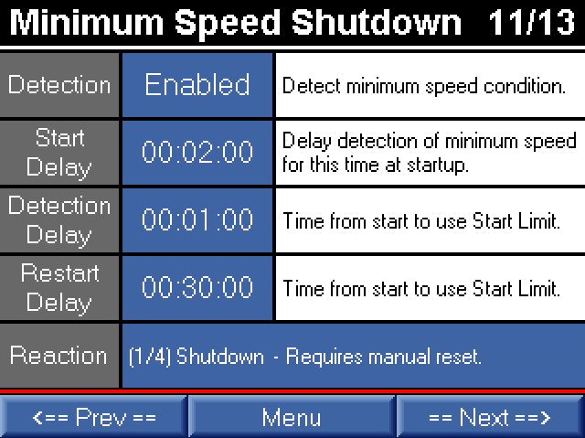When enabled, Minimum Speed Detection allows the controller to detect that the motor is running at or below the set Minimum Speed, and shut down after a predetermined time. This provides extra equipment protection for conditions that result in the output speed being pushed lower than the desired speed, such as current or torque limiting strongly engaging for an extended period of time.

The detection of a minimum speed condition will be ignored for the time set in Start Delay at startup. After the Start Delay elapses, the Detection Delay will apply. Once a minimum speed condition is detected after the Start Delay, the condition must remain present for the time set in Detection Delay in order to trigger a reaction to the condition.

Once a minimum speed condition is set, the Reaction will apply. The Reaction to the condition can be to shutdown the system or simply indicate the condition as an alarm. Both of these conditions can be configured for manual or timed reset.

**Reaction**

*Shutdown – Requires manual reset.*

*Shutdown – Restart after Restart Delay.*

*Alarm indication – Requires manual reset.*

*Alarm indication – Clears after Restart Delay.*

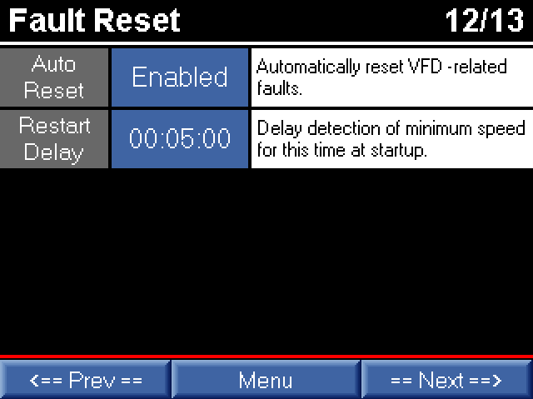In the event of a VFD-related fault, the OptiPump PC controller can be configured to automatically reset the fault condition by enabling the Auto Reset parameter. The controller will wait for the time configured in Restart Delay before initiating the restart.

The Auto Reset feature is recommended to be disabled in order to catch and notify the user of a potential issue with the application or equipment. If needed as a short-term bypass or for dealing with a known site-related issue, the Auto Reset feature can be enabled until the issue can be fully resolved. In general, VFD-related faults should not occur during proper and normal operation of the equipment.

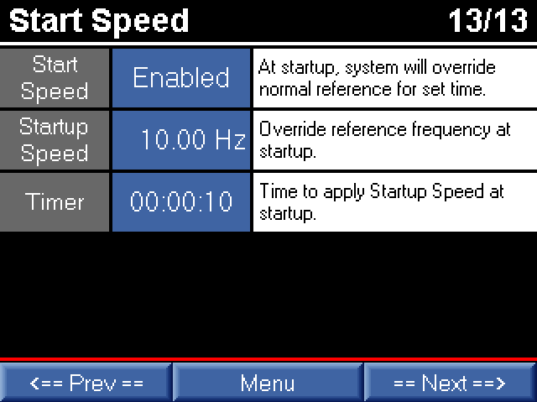In some circumstances, allowing the controller to override the desired speed for a period of time at startup can be beneficial. Enabling the parameter Start Speed will override the normal operating mode speed to the Startup Speed for the time set in Timer.

Once the time set in Timer elapses, the Start Speed parameters no longer apply until the system stops, and the cycle starts over again.

|  |
| --- |
| **Analog Input Parameters** |

|  |  |  |
| --- | --- | --- |
| Analog 01.png |  | Analog 02.png |

The analog input screens are responsible for configuring all aspects of each associated analog input. For ease of use, the current input value (mA or VDC) is displayed at the top of the screen.

The Input Name / Description is a user-defined name for the input that will be displayed on the Home Screen in the event of an alarm or shutdown, and provides a more application or site-specific meaning than a generalized name.

As part of the commissioning process, the analog inputs should be scaled into meaningful engineering units. The Low Range, High Range, and Units parameters scale the 4-20 mA or 0-10 VDC inputs.

**Low Range**

The display value for 4 mA or 0 VDC.

**High Range**

The display value for 20 mA or 10 VDC.

***Units***

Up to 5 characters that represent the engineering units associated with the input.

The analog input alarms and shutdowns are also configured on these screens. The units displayed next to the low and high setpoints will change based on the value entered in the Units parameter.

**Low/High Shutdown/Alarm**

Setpoint based on the scaled (engineering units) of the analog input that triggers an alarm or shutdown. For a Low Shutdown/Alarm, the value must be equal to or less than the setpoint. For a High Shutdown/Alarm, the value must be equal to or greater than the setpoint.

**Low/High Start Delay**

The low or high analog input condition will be ignored for the time set in Start Delay during startup.

**Low/High Detect Delay**

The low or high analog input condition must be present for the time set in Detect Delay after the Start Delay has elapsed before an alarm or shutdown will be set.

**Low/High Restart Delay**

If a low or high alarm or shutdown has been set and the associated Low/High Action is configured to automatically clear or reset, the condition will automatically clear or reset after the time set in Restart Delay has elapsed.

**Low/High Action**

*Shutdown – Requires manual reset.*

*Shutdown – Restart after Restart Delay.*

*Alarm Indication – Requires manual reset.*

*Alarm Indication – Clears after Restart Delay.*

*Monitor Only – No shutdown or alarm.*

*Analog Input Disabled.*

|  |
| --- |
| **Digital Input Parameters** |

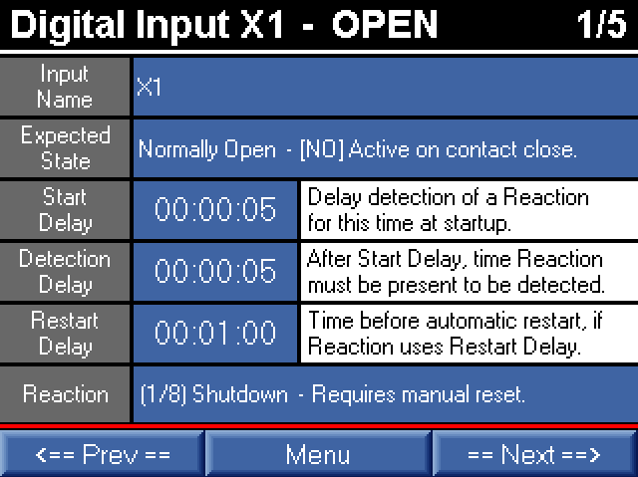The OptiPump PC controller has 5 general-purpose, digital inputs available for field use. As all 5 inputs are configured similarly, only the configuration screen for Digital Input X1 is shown to the left.

The digital inputs expect a dry contact closure between the input and the CM terminal. Do NOT apply external voltage of any level to the digital input. The input and/or VFD may be permanently damaged.

The digital input screens are responsible for configuring all aspects of each associated digital input. For ease of use, the current state of the input (OPEN or CLOSED) is displayed at the top of the screen.

In addition to providing alarm and shutdown capabilities, the general-purpose, digital inputs can also be configured as momentary start/stop or maintained run inputs. These additional functions are selections of the Reaction parameter.

The Input Name is a user-defined name for the input that will be displayed on the Home Screen in the event of an alarm or shutdown, and provides a more application or site-specific meaning than a generalized name.

**Expected State**

*Normally Open – (NO) Active on contact close.*

*Normally Closed – (NC) Active on contact open.*

**Start Delay**

The active condition of the digital input will be ignored for the time set in Start Delay during startup.

**Detection Delay**

The active condition of the digital input must be present for the time set in Detect Delay after the Start Delay has elapsed before an alarm or shutdown will be set.

**Restart Delay**

If an alarm or shutdown has been set and the Reaction is configured to automatically clear or reset, the condition will automatically clear or reset after the time set in Restart Delay has elapsed.

**Reaction**

*Shutdown – Requires manual reset.*

*Shutdown – Restart after Restart Delay.*

*Alarm Indication – Requires manual reset.*

*Alarm Indication – Clears after Restart Delay.*

*Momentary Input to Start*

*Momentary Input to Stop*

*Maintained Input to Start*

*Digital Input Disabled*

|  |
| --- |
| **Home Screen Parameters** |

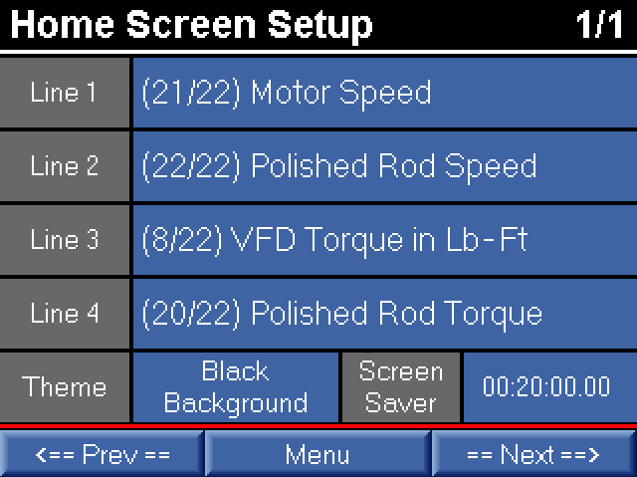The Home Screen can be customized to the needs of the individual user or site, and is the screen that will be most often viewed by users.

Two color themes are available for the Home Screen. The White Background is the classic theme historically used by many of our controllers. The Black Background provides an updated, high-contrast Home Screen that is easily viewable in bright sunlight.

The Screen Saver time will automatically turn off the display after the period of touchscreen inactivity set in the parameter.

The 4 monitors shown on the Home Screen are user-selectable from the following:

*VFD Desired Speed*

*VFD Output Speed*

*VFD Output Amps*

*Xformer Output Amps*

*VFD Output Voltage*

*Xformer Output Volts*

*VFD Torque in %*

*VFD Torque in Lb-Ft*

*Motor HP*

*Analog Input C1*

*Analog Input V2*

*Gas Potential*

*Polished Rod Torque*

*Motor Speed*

*Polished Rod Speed*

|  |
| --- |
| **Logging Parameters** |

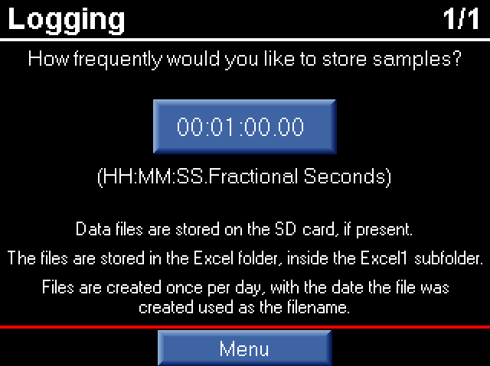When used with an optional, properly-formatted SD card, the OptiPump PC controller will automatically log samples of the following data at the interval set on this screen. The files are stored in the Excel folder, inside the Excel1 subfolder on the SD card. For convenience, the files are created once per day, with the date the file was created used as the filename.

The SD card formatting utility can be obtained by contacting the Technical Support Department or your distributor.

The following data is stored in the CSV file:

*Date*

*Time*

*Motor Amps*

*Motor Voltage*

*Motor Speed (Hz)*

*Torque Lb-Ft*

*DC Bus Volts*

*Heat Sink T Deg C*

*VFD Board Deg C*

|  |
| --- |
| **Advanced Parameters** |

The Advanced Parameters are parameters that are not typically needed during the commissioning of a new site, but can be helpful in troubleshooting or 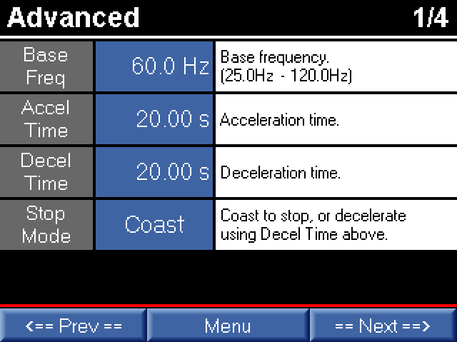meeting requirements of non-standard applications.

The Base Frequency should be set to the rated frequency listed on the nameplate of the motor.

The Accel Time and Decel Time parameters apply when changing speeds, including starting and stopping, and determine how fast or slow these changes occur.

The Stop Mode controls the stopping behavior of the VFD. When set to Coast, the drive immediately cuts off the output when a stop command is given. This allows the motor to freewheel until it comes to a stop. When set to Decel, the time set in Decel Time applies, and brings to motor to a stop in a controlled manner.

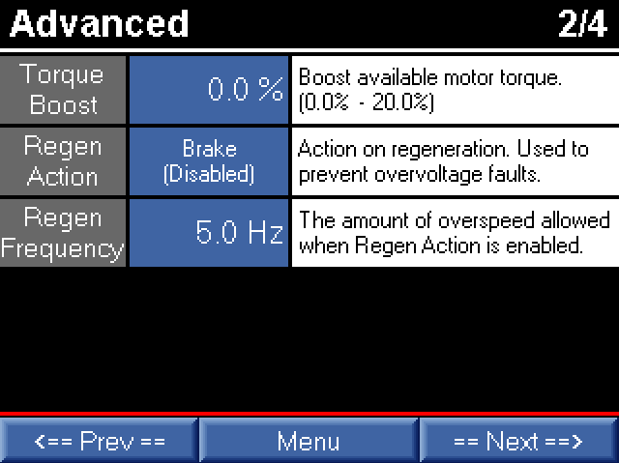Torque Boost can supply extra torque by increasing the output voltage at low speeds for hard-to-start applications. Torque Boost only applies when the VFD Mode is set to V/Hz Mode. When configured for Torque-Vector Mode, the torque is controlled automatically by the VFD, so Torque Boost does not apply.

Occasionally, PC pump applications may suffer from regen – meaning that the motor and polished rod are running faster than the VFD output frequency. This means that voltage is regenerated back into the VFD, which raises the DC bus voltage. The rise in DC bus voltage can result in an overvoltage fault. Setting the Regen Action to Control By Torque or Control By DC Bus Voltage may prevent the overvoltage fault from occurring in this situation. If either of these methods does not resolve the overvoltage fault, the amount of overspeed allowed in parameter Regen Frequency may be increased.

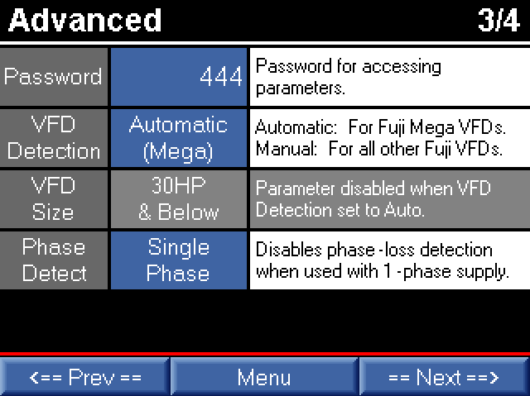The Password protects the Setup Menu, and can be changed by the user. Only numbers can be used.

When used with a Fuji Mega VFD, set the VFD Detection to Automatic (Mega). The OptiPump PC controller will automatically configure the VFD for use with the controller and full communication capabilities will be available.

When used with a single-phase supply, the system will need to be configured to ignore this phase-loss condition. Set the parameter Phase Detect to Single Phase when used with a single-phase supply, and Three Phase when used with a three-phase supply.

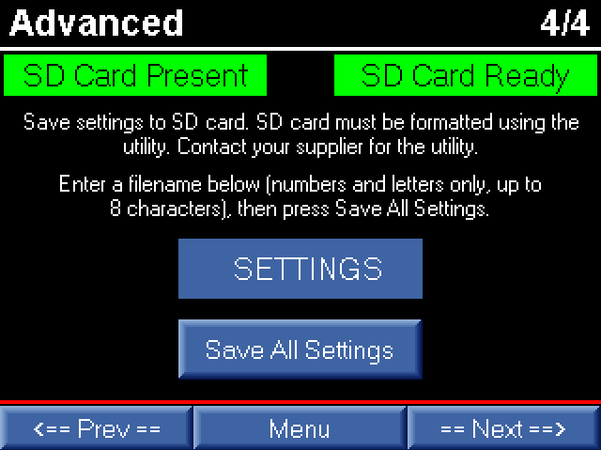The parameters configured in the OptiPump PC controller can also be saved to the SD card, if available. As with the data logging, a properly formatted SD card must be installed in the controller.

The SD card formatting utility can be obtained by contacting the Technical Support Department or your distributor.

Enter a filename in the blue box using numbers and letters only, and up to 8 characters. Then press the Save All Settings button to write the parameter values to the SD card.

Settings can be loaded from the SD card into the controller only if the firmware versions are identical. If the version of the controller does NOT match the version of the controller the parameters were saved from, DO NOT load the parameters into the controller. Unexpected behavior and operation may result.

# Factory Reset

To reset the OptiPump PC controller to factory settings, including clearing the history, perform the following:

1. Remove power from the controller.
2. Remove the Battery door located on the back of the controller on the left side.
3. Remove the coin battery from the holder.
4. Wait approximately one minute for the internals of the controller to fully discharge.
5. Reinstall the coin battery in the holder.
6. Reinstall the Battery door.
7. Apply power to the controller.
8. Reconfigure the controller as necessary.

# Technical Support



4323 South Elwood Avenue

Tulsa, OK 74107

918.445.1254 / 800.364.0458

www.aidusa.com